**An Unsupervised Neural Attention Model for Aspect Extraction**

Abstract

Aspect extraction is an important and challenging task in aspect-based sentiment analysis.

1 Introduction

For example, in the sentence “The beef was tender and melted in my mouth”, the aspect term is “beef”. Two sub-tasks are performed in aspect extraction:

(1) extracting all aspect terms (e.g., “beef”) from a review corpus,

(2) clustering aspect terms with similar meaning into categories where each category represents a single aspect (e.g., cluster “beef”, “pork”, “pasta”, and “tomato” into one aspect food).

Previous works for aspect extraction can be categorized into three approaches: rule-based, supervised, and unsupervised.

2 Related Work

3 Model Description

The ultimate goal is to learn a set of aspect embeddings, where each aspect can be interpreted by looking at the nearest words (representative words) in the embedding space. The aspect embeddings are used to approximate the aspect words in the vocabulary, where the aspect words are filtered through an attention mechanism.

Each input sample to ABAE is a list of indexes for words in a review sentence. Given such an

input, two steps are performed as shown in Figure 1. First, we filter away non-aspect words by down-weighting them using an attention mechanism, and construct a sentence embedding zs from weighted word embeddings. Then, we try to reconstruct the sentence embedding as a linear combination of aspect embeddings from T. This process of dimension reduction and reconstruction, where ABAE aims to transform sentence embeddings of the filtered sentences (zs) into their reconstructions (rs) with the least possible amount of distortion, preserves most of the information of the aspect words in the K embedded aspects.

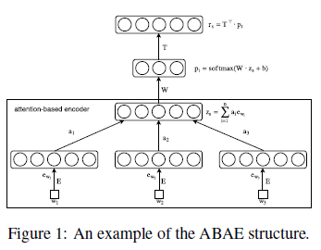

3.1 Sentence Embedding with Attention Mechanism

We construct a vector representation zs for each input sentence s in the first step.

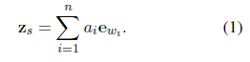

For each word wi in the sentence, we compute a positive weight ai which can be interpreted as the probability that wi is the right word to focus on in order to capture the main topic of the sentence. The weight ai is computed by an attention model, which is conditioned on the embedding of the word ewi as well as the global context of the sentence:

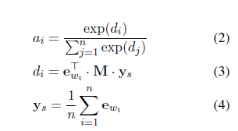

where ys is simply the average of the word embeddings, which we believe captures the global context of the sentence.

We can think of the attention mechanism as a two-step process. Given a sentence, we first construct its representation by averaging all the word representations. Then the

weight of a word is assigned by considering two things. First, we filter the word through the transformation M which is able to capture the relevance of the word to the K aspects. Then we capture the relevance of the filtered word to the sentence by taking the inner product of the filtered word to the global context ys.

3.2 Sentence Reconstruction with Aspect Embeddings

Intuitively, we can think of the reconstruction as a linear combination of aspect embeddings from T:

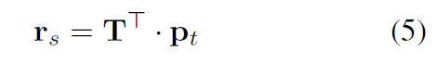

where rs is the reconstructed vector representation, pt is the weight vector over K aspect embeddings, where each weight represents the probability that the input sentence belongs to the related aspect. pt can simply be obtained by reducing zs from d dimensions to K dimensions and then applying a softmax non-linearity that yields normalized non-negative weights:



Where W, the weighted matrix parameter, and b, the bias vector, are learned as part of the training process.

3.3 Training Objective

ABAE is trained to minimize the reconstruction error.

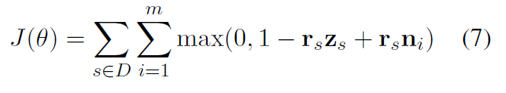

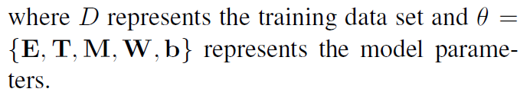

3.4 Regularization Term



U reaches its minimum value when the dot product between any two different aspect embeddings is zero.

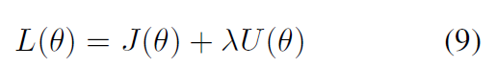

4 Experimental Setup

5 Evaluation and Results

We evaluate ABAE on two criteria:

Is it able to find meaningful and semantically coherent aspects?

Is it able to improve aspect identification performance on real-world review datasets?

5.1.1 Coherence Score

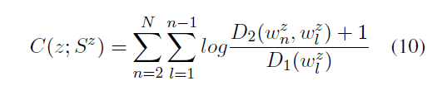

5.1.2 User Evaluation

5.2 Aspect Identification

Given a review sentence, ABAE first assigns an inferred aspect label which corresponds to the highest weight in pt calculated as shown in Equation 6. And we then assign the gold-standard label to the sentence according to the mapping between inferred aspects and gold-standard labels.

5.3 Validating the Effectiveness of Attention Model

6 Conclusion

We have presented ABAE, a simple yet effective neural attention model for aspect extraction. In contrast to LDA models, ABAE explicitly captures word co-occurrence patterns and overcomes the problem of data sparsity present in review corpora. Our experimental results demonstrated that ABAE not only learns substantially higher quality aspects, but also more effectively captures the aspects of reviews than previous methods. To the best of our knowledge, we are the first to propose an unsupervised neural approach for aspect extraction. ABAE is intuitive and structurally simple, and also scales up well. All these benefits make it a promising alternative to LDA-based methods in practice.